**BANDGUARD**

**- A Safeguard for Women**

***Submitted by***

**MYTHILI R 212218205030**

**MATHIYAZHAGI B 212218205027**

**ABARNA M 212218205001**

**MEDASANI LIKHITHA 212218205028**

**BANDARU KRISHNA 212218205007**

**KEERTHANA**

***in partial fulfillment for the award of the degree***

***of***

**BACHELOR OF TECHNOLOGY**

**in**

**INFORMATION TECHNOLOGY**





**SAVEETHA ENGINEERING COLLEGE (AUTONOMOUS)**

**APRIL 2021**

**SAVEETHA ENGINEERING COLLEGE (AUTONOMOUS)**

**BONAFIDE CERTIFICATE**

Certified that this project report **“A Innovative Machine learning Approach For Diabetes Mellitus Prediction.”** is the bonafide work of **NIRMAL D (212217205035), PRAVEENRAJ R (212217205040), ROBINSON P(212217205049),** who carried out the project work under my supervision.

**SIGNATURE SIGNATURE**

**Dr. P. VALARMATHIE, M.E., Ph.D., Dr.G. Nalinipriya,M.E.,Ph.D.,**

Professor Professor

**HEAD OF THE DEPARTMENT SUPERVISOR**

Dept of Information Technology, Dept of Information Technology,

Saveetha Engineering College, Saveetha Engineering College,

Thandalam, Chennai -602105. Thandalam,Chennai -602105.

DATE OF THE VIVA VOICE EXAMINATION: ……………………..

**INTERNAL EXAMINER** **EXTERNAL EXAMINER**

**ACKNOWLEDGEMENT**

We express our deep sense of gratitude to our honorable and beloved Founder President ***Dr. N. M. Veeraiyan,*** our President ***Dr. Saveetha Rajesh,*** our Director ***Dr. S.Rajesh*** and other management members for providing the infrastructure needed.

We express our wholehearted gratitude to our principal, ***Dr. R. Ramesh,*** for his whole hearted encouragement in completing this project.

We convey our thanks to ***Dr. P. Valarmathie,*** Professor and Head of the Department of Information Technology, Saveetha Engineering College, for her kind support and for providing necessary facilities to carry out the project work.

We would like to express our sincere thanks and deep sense of Gratitude to our Supervisor **Dr.G. Nalinipriya , M.E.,Ph.D.,** Professor , Department of Information Technology, Saveetha Engineering College for her valuable guidance, suggestions and constant encouragement that paved the way for the successful completion of the project work and for providing us necessary support and details at the right time and during the progressive reviews. We owe our thanks to all the members of our college, faculty, staff and technicians for their kind and valuable cooperation during the course of the project. We are pleased to acknowledge our sincere thanks to our beloved parents, friends and well-wishers who encouraged us to complete this project successfully.

**ABSTRACT**

Women Empowerment has laid a strong foundation by raising the standards of women in all the fields, especially in the field of education. Nowadays every women is working and they strive hard for their growth of their family and society. On the same side, the crime against women are increasing day by day in all aspects and the world is becoming vulnerable for women to survive. Not only women, girl children too faces the same crises, they are not feeling safe due to increasing crimes; there is a feeling of insecurity amongst the women, girl children and their family members. Hence, by analyzing through various views of women insecurity we came to a conclusion with a proposed solution for resolving this issue with the help of BAND_GUARD - a GPS based women safety system which has a dual security feature. It is a system that ensures dual alerts in case a woman or girl child is harassed, kidnapped by someone or she thinks she is in trouble. This band guard is an hairband which is used by all the women and girl children in their day-to-day life, in which a GPS tracker is being placed with the inbuilt SOS Panic button with power source inbuilt battery with waterproof coating material. The GPS tracker with SOS Panic button, which is used to send alert messages and to share current location of the user that is women or girl children, which will be sent to their family or friends. This device will be turned on by clicking the SOS Panic button in advance by the women or girl children when they walk alone in the street or in a strange or unsecure situation and girl children are advised to turn on this device while they get off from the school. So that their parents will be tracking the location of the children without the feeling of insecurity and this can be located with the help of Google Maps by GPS tracking methodology. The main purpose of this device BAND_GUARD is to intimate the parents or friends or guardian about the current location of the women or girl children. An inbuilt GPS system is used to trace the current position of the victim and the message or notifications will be sent to the pre-defined numbers.

|  |  |  |
| --- | --- | --- |
|  | **TABLE OF CONTENTS** |  |
| **CHAPTER** | **TITLE** | **PAGE NO** |
|  | **ABSTRACT** | I |
| **LIST OF FIGURES** | IV |
| **LIST OF ABBREVATION** | V |
| **1** | **INTRODUCTION** |  |
|  | 1.1 OVERVIEW | **9** |
| 1.2 PROBLEM DEFINITION | **9** |
| 1.3 SCOPE | **10** |
| **2** | **LITERATURE SURVEY** |  |
|  | 2.1 SURVEY DESCRIPTION | **11** |
| **3** | **SYSTEM ANALYSIS** |  |
|  | 3.1 EXISTING SYSTEM | **16** |
| 3.2 PROPOSED SYSTEM | **17** |
| **4** | **SYSTEM SPECIFICATION** |  |
|  | 4.1 HARDWARE SPECIFICATION | **18** |
| 4.2 SOFTWARE SPECIFICATION | **20** |
| **5** | **SYSTEM IMPLEMENTATION** |  |
|  | 5.1 SYSTEM ARCHITECTURE | **25** |
| 5.2 MODULES | **26** |
|  | 5.2.1 GPS MODULE  5.2.2 GSM MODULE  5.2.3 CIRCUIT ANALYSIS | **27** |
| **6** | **SYSTEM DESIGN** | **28** |
|  | 6.1 DATA FLOW DIAGRAM | **29** |
| 6.2 UML DIAGRAM | **30** |
| 6.2.1 USE CASE DIAGRAM | **31** |
| 6.2.2 SEQUENCE DIAGRAM | **32** |
| 6.2.3 ACTIVITY DIAGRAM **33** |  |
|  | 6.2.4 CLASS DIAGRAM **34**  6.3 BLOCK DIAGRAM **35**  6.4 FLOW CHART **35** |  |
| **7** | **SYSTEM TESTING** |  |
|  | 7.1 TESTING OBJECTIVES | **36** |
| 7.2 SYSTEM TESTING | **36** |
| 7.3 TESTING LEVEL |  |
| 7.3.1 UNIT TESTING | **37** |
| 7.3.2 INTEGRATION TESTING | **38** |
| 7.3.3 VALIDATION TESTING | **39** |
| **8** | **CONCLUSION AND FUTURE**  **ENHANCEMENT** |  |
|  |
|  | **APPENDICES** |  |
|  | APPENDIX A: SOURCE CODE | **41** |
| APPENDIX B: SNAP SHOTS | **63** |
|  | **REFERENCES** | **66** |
|  |  |  |

**LIST OF FIGURES**

**FIGURE NO NAME OF THE FIGURE PAGE NO**

1 System Architecture **25**

2 Transmitter circuit diagram **27**

3 Receiver circuit diagram **28**

4 Data Flow Diagram **29**

5 UseCase Diagram **30**

6 Sequence Diagram **31**

7 Activity Diagram **32**

8 Class Diagram **33**

9 Block Diagram **34**

10 Flow Chart **35**

11 Alert Message Received **61**

12 Location Tracked in Google Map **62**

13 Exact Location of Victim is tracked **62**

14 Band_Gaurd Implementation Outcome  **63**

**LIST OF ABBREVIATION**

**ABBREVIATION EXPANSION**

GPS Global Positioning system

SOS Save Our Souls

GSM Global System for Mobile Communication

SIM Subscriber Identification Module

IDE Intergrated Development Environment

GPRS General Packet Radio Service

**CHAPTER 1**

**INTRODUCTION**

* 1. **OVERVIEW**

Neworking is one of the biggest domains where you can connect to multiple devices, keep track of devices. Today, everything uses network to share, communicate, keep tracking, and so on. Networking is a Digital Telecommunication Network which allows nodes to share resources. These data links are established over cable, wireless media.

GPS is now everywhere. But school children, women who are in help, who are abducted by kidnappers whose phone will be ceased by the kidnappers will be in a great danger. So, for women’s safety we have planned a Rubber band GPS in which GPS tracker is placed in rubber band. An SOS button is also placed in the GPS tracker. It is a panic button. When women are in danger, they just need to press the button. The information i.e., the location is shared to their parents or relatives and to the nearby Police station.

The idea to develop a smart device for women is that it’s completely comfortable and easy to use as compared with already existing women security solutions such as a separate garment, bulky belts and in famous mobile apps that are just very abstract and obsolete. If a woman is subjected to attack by an adversary, then a switch has to be pressed by her, manually, (which will be ideally located at a Rubber band), which sends the location information.

* 1. **PROBLEM DEFINITION**

Nowadays we have seen many women, young girls and mothers disappearing and facing physical and sexual harassment from public places, streets and public transport. Many cases are being filed on a regular basis on issues such as kidnapping, harassments or assaults and these crimes are increasing day by day. Every woman is working and they strive hard for their growth of their family and society. On the same side, the crime against women is increasing day by day in all aspects and the world is becoming vulnerable for women to survive. Not only women, girl children too face the same crises, they are not feeling safe due to increasing crimes; there is a feeling of insecurity amongst the women, girl children and their family members. Hence, by analysing through various views of women insecurity we came to a conclusion with a proposed solution for resolving this issue with the help of BAND-GUARD - a GPS based women safety system which has a dual security feature. It is a system that ensures dual alerts in case a woman or girl child is harassed, kidnapped by someone or she thinks she is in trouble. This band guard is an hairband which is used by all the women and girl children in their day-to-day life, in which a GPS tracker is being placed with the inbuilt SOS Panic button with power source inbuilt battery with waterproof coating material.

The GPS tracker with SOS Panic button, which is used to send alert messages and to share current location of the user that is women or girl children, which will be sent to their family or friends. This device will be turned on by clicking the SOS Panic button in advance by the women or girl children when they walk alone in the street or in a strange or unsecure situation and girl children are advised to turn on this device while they get off from the school. So that their parents will be tracking the location of the children without the feeling of insecurity and this can be located with the help of Google Maps by GPS tracking methodology. The main purpose of this device BAND_GUARD is to intimate the parents or friends or guardian about the current location of the women or girl children. An inbuilt GPS system is used to trace the current position of the victim and the message or notifications will be sent to the pre-defined numbers.

* 1. **SCOPE**

As the mechanical changes or new prerequisite from client to

improve the usefulness of item may requires new form to present. In spite of the fact that the Framework is finished and working effectively, new modules which improve the framework usefulness can be added with no real changes to the whole framework. Among the different modules few are distinguished, which couldn't be incorporated into the last augmentation because of time requirements. These are as per the following Grade School Youngsters Wellbeing: As the school kid’s security is real attentiveness toward guardians and in addition school administration because of the current episodes of tyke violations like kids missing, manhandle and so forth. This module screens the tyke security when they are going in school transports. When they achieved the school the gadget gets deactivated by school expert and message send the guardians that, "the tyke achieves the school securely". At return travel again the gadget is actuated by school specialist and when they achieved the home, the recognize message is send to the school when guardians deactivate the gadget. The gadget is fit for sound recording

when initiated that can tune in by the guardians or approve individual. Portable and different resources Security Framework Module: Additionally a similar gadget can connect to our baggage, subsequently if there should arise an occurrence of neglecting to pick back or attempt to stolen by somebody can be effortlessly seen by the module and make the consideration of client through the siren caution. Thus, the propel innovation makes the framework more vigorous and solid. As the new modules give the usefulness which upgrade the wellbeing and security. Therefore it satisfies the motivation behind the venture.

**CHAPTER 2**

**LITERATURE SURVEY**

**2.1 SURVEY DESCRIPTION**

**Sutar Meghaetal [1] The Sexual Harassment of Women at Workplace (Prevention, Prohibition and Redressal) Act,2013** is a legislative act in India that seeks to protect women from sexual harassment at their place of work. Today women are playing an important role as a president, prime minister, speaker of the Lok Sabha and even in the field of aeronautics, military, IPS, IAS, etc. Even today women have achieved top positions in job and society, yet they are facing problems such as physical harassment and the sexual assault. The cases of harassment and rapes on women are increasing hence security issue for such woman is more important. So, it is essential to develop a system to provide security to women. In this he devised a system allows women to protect themselves from attackers. In recent days the attacks on women are increasing and sometimes they are not even able to take their mobile and dial-up to police, this system will help women in such situations to inform about attacks and also in giving their exact location to a nearby police station for necessary action. In this, the author designed a device, in that, by pressing the button of the device a message along with her location will be transmitted by the system to the police station and her few relatives, so that they will get aware of her current situation. He told that with that message she is also for their defensive purpose they can able to give a shock to the attacker it will be more helpful to women at that critical situation, this system is designed as the defence equipment, it will them to attack the attacker. So, she has some time to rescue herself from that attacker.

**Anup.C.Jetal [2] The amount of violence against women has increased by many folds due to the greater exposure of women in every field of life.** Women were previously restricted to the four walls of the houses and after globalization, they have got the chances and opportunities to stand equally in all sectors at compare with male. Women are now a day’s cab drivers and they are also the CEO of top companies. It is a good sign that the patriarchal mindset of the society has changed to some extent but not to the extent it was supposed to. It is the same mindset that restricts women to go out and work making them as a tool for domestication. It is the same mindset that treats males as superior than female and always try to dominate the womenfolk. There are different kinds of tools that are being used by the male-dominated society to prove their domination over the female. Eve teasing, sexual harassment, rape, domestic violence against women are these weapons used by the male to display the male superiority. This is one of the prime reason violence is increasing in India and women safety is a concern in India.

**Shreyaasha chaudauryet al [3] Safety of Women in India has become a major issue in India now.** The crime rates against women in the country have only risen to a great extent. Women think twice before stepping out of their homes, especially at night. This is, unfortunately, the sad reality of our country that lives in constant fear. Women in India have been given equal rights as men; however, people do not follow this rule. They contribute to the growth and development of our country; still, they are living in fear. Women are now on respected positions in the country, but if we take a look behind the curtains, we see even then they are being exploited. Each day we read about horrific crimes being committed against women in our country. In our daily life, where you don’t hear the news of a crime against women in India. In fact, there are at least five news articles that tell us About the horrific details of the various crimes. It is extremely painful to watch the status of women’s safety in India, especially in a country where women are given the stature of goddesses. To avoid situations like this, in this the author designed a device with a sensor called IoT to protect women from danger .

**Snehal Lokesh et al [4] , Violence against women and girls does not discriminate by race, religion, culture, class or country.** Worldwide, one in three women have experienced either physical and/or sexual violence, and more than 15 million girls aged 15-19 years have experienced rape. Conflict and displacement only heighten the problem. As girls and women lose their support systems and homes, are placed in insecure environments and in new roles, their risk of gender-based violence (GBV), including sexual violence, intimate partner violence and child abuse increases day by day. Areas like streets, public spaces, public transport, etc. have been the territory of women hunters. Every day and every minute some women of all walks of life (a mother, a sister, a wife, young girls, and girl baby children) are getting harassed, molested, assaulted, and violated at various places all over the country.

**Swati Sharma et al [5] , Safety for women become a matter of concern with the violence against the women will increases, in this system the GPS tracking and messaging system plays an important role.** When women are going to travel somewhere for long distances at night time the GPS used as a GPRS location while travelling in the cab would be accessible and simultaneously her location will be immediately sent to their relative for their rescue. The main purpose of designing such a project is that we will make small, handy equipment, which could be kept in a purse. This equipment will be having a panic switch and as soon as the panic switch is pressed, the location coordinates provided by the GPS to the emergency. The panic switch is very small and it will easily handle with safe and secure from others and that is an easy way to do this. While press that switch an emergency/alert message about the victim location gets shared to the police control room and will be informed through the ease of the website.

**Junaid Mohammed et al [6] this paper is built on the android app based on their mobile application for the health monitoring.** They developed an application called ECG android app, which provides the user with the visualization of their Electro Cardiogram (ECG). waves and the data logging functionality in the background, the sorted data can be upload in the Wi-Fi cloud, which monitors the records of the future analysis for the person, by this idea will develop an internet of things and cloud techniques. The IOIO microcontroller, signal processing, communication protocols, secure and efficient mechanism of large file transfer, database management system and the cloud. ECG waves visualization on the Android App. The ECG waves were plotted by the data transmitted from the sensors on the IOIO microcontroller via Bluetooth technology. ECG data logging on the Android App: The large amount of data received from the IOIO microcontroller is covered to a binary file which would contain all the data received and this file would be stored on the SD card of the mobile phone. This feature improves the performance and scalability. An Upload Service: The service uploads the files on the SD card of a device to a private centralized cloud using an FTPES secure server. The transfer of the file takes place using File Transfer Protocol over the Internet Protocol. We have developed the ability to store unstructured data on a File system without causing any form of latency within the database using filletable and File stream technology in Microsoft SQL Server 2012. Multiple devices can pass ECG data to the server at the same time as the cloud has multi-user and multi-device support. File Compression and Security. The medical data is stored in a binary format which would be encrypted and uploaded to the cloud in a secure manner using FTPES protocol. The format is optimized for compact storage and faster byte parsing on the cloud which is later used for visualization with MATLAB or any signal processing software.

**The paper [7] proposes an application called women empowerment. This application can be installed in the smart phones.** This application has mainly three modules they are, Violence against Women (VAW), Women’s Health (WH), Emergency Call System (ECS). To use the above options user needs to sign in her/him only once. Different laws are included by VAW related to women. Crime related laws can be easily seen by user and take an appropriate decision to avoid crime which helps women to be conscious. It includes some cell number of lawyers and NGOs, where in the victim can access those numbers to get justice. WH includes women’s health issues related to breast cancer, breastfeeding, fitness and nutrition, issues related to HIV/AIDS, mental health, pregnancy, vaccines etc. As women of our country are mostly working and are not health conscious, this application helps them to record their physical changes and help them instead of going to the doctor frequently. This application not only takes care about the health but it also helps women in difficult environment or when a threat arises. Emergency Call System (ECS) which will be activated by the user. Initially a user has to set an emergency contact number and can also save templates. When users are in danger they just need to press a particular button then this system will make three successive calls and sends a text message which was previously saved to the present number. It also sends the location of the user using the Global Positioning System (GPS) in text message. Advantage of this app are unlike many other applications it not only just sends the location of victim to his/her family and the health related issues to women members but also helps in giving knowledge about the laws.

**The paper [8] focuses on a security system that is designed merely to serve the purpose of providing security to women so that they never feel helpless.** This paper talks about all the devices that are already developed for women safety such as, SHE (Society Harnessing Equipment): This device can generate 3800KV and provide electric shock to the victims, ILA security: It includes three alarms which can provide shock, disorient potential attacker, AESHS (Advanced Electronics System for Human Safety): it includes GPS module, Smart Band: It consists of a smart band module that contains Bluetooth low energy (BLE), motion sensors, Pulse rate sensors, temperature sensor. Smart band does 3 things, firstly Messages to family along with co-ordinates are sent, secondly the location is sent to nearest police station and at last it sends information to people near the surrounding requesting public attention. Advantages of this smart band are it uses many different sensors and hence it can be truly effective and trustworthy. It is integrated with smart phone hence low cost and it uses BLE (Bluetooth Low Energy) therefore power consumption is less.

**The paper [9] proposes a concept of portable equipment which can be carried by the women which consists of a GPS, GSM model, LCD display and a physical button.** This equipment is designed using the ARM 7 micro controller LPC2148. The advantages of this equipment is it consumes low power as it uses arm controller which are more efficient in the present days, it also includes notifying the related authority for taking necessary actions on the culprits. This system can be made much better by installing a camera so that the culprits can be easily captured.

**The paper [10] conducts a survey of 10 papers which are on women safety and security.** It categorizes the technologies used in the papers into three categories and list outs the disadvantages of all and proposed a model which included the features of all the technologies and added few more to them to overcome disadvantages and provide a better security system for the women. The proposed model included.

i)Auto receiving call module - it helps to receive the call from registered contacts on the victim's safety device.

ii) Spy camera detection module - which helps to detect the spy cameras in the changing rooms of shops and other places.

iii)Fake call Tool Module- which helps in creating a fake incoming call which in turn helps women to escape from a bad situation, it acts like a precautionary measure.

iv)Generate Electric Shock module - it helps in creating a high voltage electric shock which acts as a self-defence device when women is in a threat.

**CHAPTER 3**

**SYSTEM ANALYSIS**

**3.1 EXISTING SYSTEM**

In November 2012, The WHO Department of Reproductive Health and Research formed a group of specialists to examine well-being segment-based research to react to savagery against women [5]. Numerous researches show that safety of being harassed could be made through many ways, which is under developing. Earlier this system developed an app which required a Smartphone. From the research paper by Ashwini.P. Thus it is seen that this device had a great use for women safety too.[6] She developed a one-touch alarm based device including an emergency call for helping which did not require a Smartphone.

Likewise Smart device,Voice app,SHE,AESHS,VithU app,Smart Belt. But these smart GPS tracking devices are not so effective and these apps may be destroyed because emergency alert sms send out through your main balance(smart phone).If you are in emergency situation you have insufficient balance the alert sms won’t delivery then the entire system will be destroyed. The existing system describes an equipment which consists of a GPS module by which one can get the geographical location via SMS. In case of any emergency conditions, she can press a button once, and then the location will be tracked and sent to police and relation so that they will know the exact location of the individual, so that the incident could be prevented and the culprit is apprehended. There are also several kinds of applications developed in the market for women's safety and security. These applications allow the users to register themselves on the app by creating their account. After making an account, users would be qualified to use all the services intended to protect and empower them. Services include an automated distress SOS to the nearest police station and her emergency contacts. These applications can share the location only to a maximum of a single contact. Also, one needs to constantly press the button to share the location at various intervals while saving herself from emergency situations. There are some applications through which one can send pictures. When activating the camera or video option automatically on button click, sometimes an offensive photograph can also be taken, which may rarely lead to suicidal issues. So let we introduce, IOT based smart band system which will ensure to minimize the crime against women.

**3.2 PROPOSED SYSTEM**

For the purpose of giving instant safety especially women, safety devices are introduced. Day by day the functions and programs have been updated. This device has a great impact on the community. At each stage, the security device is being developed. Even the Governments of several countries are developing security device that provides security for masses. GSM based wearable safety gadgets are available and increasing. Our ultimate goal is to bring safety through our device which has GSM; GPS to track location with state-of- the-art technology refers to the top stage of development.

When this system is started GPS and GSM module will be initialized. Once GPS and GSM module are initially ready, it will be able to receive data. After pressing the push button, firstly buzzer will be buzzed continuously for 3 seconds, then the shock generator will be activated for 10 seconds. In the meantime, the Arduino will be interfaced with the GPS and GSM. And by using Global Positioning System (GPS) the current location will be received from satellite. Latitude and Longitude data will be printed and a help message will be sent to designated contact number by using GSM. If the help button is pressed again then GPS will collect latitude and longitude data again. After being processed by GSM, will be sent in the form of SMS to some designated contact number by using GSM. The main purpose of this device BAND-GUARD is to intimate the parents or friends or guardian about the current location of the women or girl children. An inbuilt GPS system is used to trace the current position of the victim and the message or notifications will be sent to the pre-defined numbers.

**CHAPTER 4**

**SYSTEM SPECIFICATIONS**

**4.1 HARDWARE SPECIFICATION**

1. Arduino Nano
2. SIM900 Modem
3. NEO6M GPS module
4. 433 MHZ RF Transmitter and Receiver
5. SOS Panic Button
6. Battery
7. Breadboard
8. Jumpers
9. **AURDINO NANO**

Arduino Nano is a microcontroller board designed by [Arduino.cc](https://www.arduino.cc/). The microcontroller used in the Arduino Nano is Atmega328, the same one as used in Arduino UNO. It has a wide range of applications and is a major microcontroller board because of its small size and flexibility.

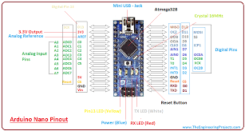

1. **SIM900 MODEM**

The SIM900 GSM/GPRS MODEM -RS232, from rhydoLABZ, is same as the [GSM-1934](https://www.rhydolabz.com/index.php?main_page=product_info&cPath=184_185&products_id=1075) except that the DB9 Connector is replaced with an RMC connector. The Modem is manufactured with Automatic Pick and place machine with high quality standard.The onboard Low dropout 3A Power supply allows you to connect wide range unregulated power supply  . Using this modem,you can make audio calls, SMS, Read SMS, attend the incoming calls and internet ect through simple AT commands.

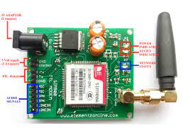

**3.NEO6M GPS MODULE**

The u-blox NEO-6M global positioning system (GPS) module, a very popular, cost-effective, high-performance GPS module with a ceramic patch antenna, an on-board memory chip, and a backup battery that can be conveniently integrated with a broad range of microcontrollers. The u-blox NEO-6M GPS engine on these modules is quite a good one, and it also has high sensitivity for indoor applications. Furthermore, there’s one MS621FE-compatible rechargeable battery for backup and EEPROM for storing configuration settings. The module works well with a DC input in the 3.3- to 5-V range (thanks to its built-in voltage regulator).

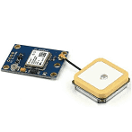

**4. 433 MHZ RF TRANSMITTER AND RECTIFIER**

The 433MHz wireless module is one of the cheap and easy to use modules for all wireless projects. These modules can be used only in pairs and only simplex communication is possible. Meaning the transmitter can only transmit information and the receiver can only receive it, so you can only send data from point A to B and not from B to A. The module could cover a minimum of 3 meters and with proper antenna a power supplies it can reach up to 100 meters theoretically. But practically we can hardly get about 30-35 meters in a normal test conditions. So if you are looking for a simple wireless communication to transmit information within a short distance then these RF pair could be the right choice.

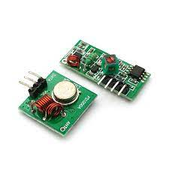

**5. SOS PANIC BUTTON**

More and more cars now have an **SOS button** linked to eCall. The eCall system automatically notifies the emergency services if your car is involved in an accident. You can also call the emergency services manually by pressing the **SOS button**. Note: this **button** should only be used in a real emergency situation.

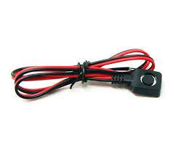

**4.2 SOFTWARE SPECIFICATION**

**SOFTWARE : AURDINO IDE**



**Programming of Arduino**

After successful completion of the Hardware connections, now it’s time for programming the Arduino Nano. The stepwise explanation of the code is given below.

Start the code by including all the required library files in the code like TinyGPS++.h for NEO6M GPS board, SoftwareSerial.h for defining the Software serial pins.

Here TinyGPS++.h library is used to get the GPS coordinates using the GPS receiver module. This library can be downloaded here.

#include <TinyGPS++.h>

#include <SoftwareSerial.h>

Now, declare the connection pins of the GPS module and its default baud rate, which is 9600 in our case. Also, define the software serial pins using which GPS will communicate with Arduino.

static const int RXPin = 2, TXPin = 3;

static const uint32_t gps_baudrate = 9600;

Then declare the objects for the TinyGPSPlus class. Also, define the object for SoftwareSerial class with the pins as arguments declared earlier.

TinyGPSPlus gps;

SoftwareSerial soft(RXPin, TXPin);

Inside setup (), declare all the input pins and output pins. Then, initialize the hardware serial and Software serial functionality, providing the default baud rate which is 9600 in our case.

void setup()

{

pinMode(12,INPUT); // Input from RF module

pinMode(4, OUTPUT); // Output for Buzzer

Serial.begin(19200);

soft.begin(gps_baudrate);

}

Inside loop (), the digital input status for pin 12 is read and stored in a variable. When this status is HIGH, which indicates that, the switch is pressed in the transmitter side, hence the Arduino turns the Buzzer ON and also calls a function sendsms(), for sending the SMS regarding Location data.

void loop()

{

int key = digitalRead(12);

if(key==1)

{

digitalWrite(4,HIGH); // Switch ON the Buzzer

sendsms();

digitalWrite(4,LOW); // Switch OFF the Buzzer

}

else;

For receiving the GPS coordinates, the code is written which continuously checks for a serial terminal for incoming data from the GPS module. When valid data is found having GPS coordinates, this is stored in two separate variables as Latitude and Longitude.

while (soft.available() > 0)

{

gps.encode(soft.read());

if (gps.location.isUpdated())

{

Lat = gps.location.lat();

Lon = gps.location.lng();

}

else;

}

}

Finally, a function written is to send the SMS to the registered number. Here the SIM900 GSM modem is set to SMS text mode using AT + CMGF command. Then the recipient’s number is defined using the format shown. You can replace this with your mobile number. Then the message with location variables appended within is sent via the serial terminal.

void sendsms()

{

Serial.print("AT+CMGF=1\r");

delay(100);

Serial.println("AT+CMGS =\"+9194XXXXXXX\””);

delay(100);

Serial.println(“I want Help !!!Location:” + String(“Lat: “) +String(Lat) + “ “+String(“Lon: “) + String(Lon));

delay(100);

Serial.println((char)26);

delay(100);

Serial.println();

delay(5000);

}

**API : GOOGLE MAP**



The Google Maps Platform is a set of APIs and SDKs that allows developers to embed Google Maps into mobile apps and web pages, or to retrieve data from Google Maps. There are several offerings. Depending on your needs, you may find yourself using one or a combination of these APIs and SDKs:

**Maps:**

* [Maps JavaScript API](https://developers.google.com/maps/documentation/javascript)
* [Maps SDK for Android](https://developers.google.com/maps/documentation/android-sdk)
* [Maps SDK for iOS](https://developers.google.com/maps/documentation/ios-sdk)
* [Maps Static API](https://developers.google.com/maps/documentation/maps-static)
* [Street View Static API](https://developers.google.com/maps/documentation/streetview)
* [Maps URLs](https://developers.google.com/maps/documentation/urls/guide)
* [Maps Embed API](https://developers.google.com/maps/documentation/embed)

**Routes:**

* [Directions API](https://developers.google.com/maps/documentation/directions)
* [Distance Matrix API](https://developers.google.com/maps/documentation/distance-matrix)
* [Roads API](https://developers.google.com/maps/documentation/roads)

**Places:**

* [Places API](https://developers.google.com/maps/documentation/places/web-service)
* [Places SDK for Android](https://developers.google.com/maps/documentation/places/android-sdk)
* [Places SDK for iOS](https://developers.google.com/maps/documentation/places/ios-sdk)
* [Places Library, Maps JavaScript API](https://developers.google.com/maps/documentation/javascript/places)
* [Geocoding API](https://developers.google.com/maps/documentation/geocoding)
* [Geolocation API](https://developers.google.com/maps/documentation/geolocation)
* [Time Zone API](https://developers.google.com/maps/documentation/timezone)

The Geolocation API returns a location and accuracy radius based on information about cell towers and WiFi nodes that the mobile client can detect. This document describes the protocol used to send this data to the server and to return a response to the client.

Communication is done over HTTPS using POST. Both request and response are formatted as JSON, and the content type of both is application/json.

An example Geolocation API request body is shown below.

{  
  "homeMobileCountryCode": 310,  
  "homeMobileNetworkCode": 410,  
  "radioType": "gsm",  
  "carrier": "Vodafone",  
  "considerIp": true,  
  "cellTowers": [  
    // See the [Cell Tower Objects](https://developers.google.com/maps/documentation/geolocation/overview#cell_tower_object) section below.  
  ],  
  "wifiAccessPoints": [  
    // See the [WiFi Access Point Objects](https://developers.google.com/maps/documentation/geolocation/overview#wifi_access_point_object) section below.  
  ]  
}

**CHAPTER 5**

**SYSTEM IMPLEMENTATION**

**5.1 SYSTEM ARCHITECTURE**

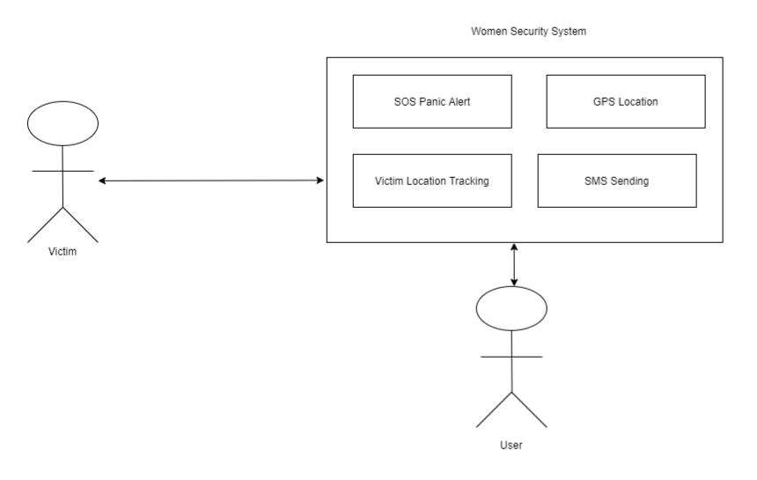

**Fig 5.1 System Architecture**

The methodology of the safety assistant harassment prevention is mentioned trough a flow chart in the figure 2. We may acquire the basic algorithms of the operations of this project from that flow chart. The direction of the operations of different components according the methods of operation is depicted through providing aero sign in each nodal paths of the block. When this system is started GPS and GSM module will be initialized. Once GPS and GSM module are initially ready, it will be able to receive data. After pressing the help button, first buzzer will be buzzed continuously for 3 seconds. In the meantime, the Arduino will interface between GPS and GSM. And by using Global Positioning System (GPS) the current location will be received from satellite. The shock generator will be activated for 10 seconds right after the buzzer. After 10 seconds the Latitude and Longitude data will be sent in the form of SMS to some designated contact number by using GSM.

**5.2 MODULES**

### **5.2.1 GPS MODULE**

Here we are using the NEO6M GPS module. The NEO-6M GPS module is a popular GPS receiver with a built-in ceramic antenna, which provides a strong satellite search capability. This receiver has the ability to sense locations and track up to 22 satellites and identifies locations anywhere in the world. With the on-board signal indicator, we can monitor the network status of the module. It has a data backup battery so that the module can save the data when the main power is shut down accidentally.

The core heart inside the GPS receiver module is the NEO-6M GPS chip from u-blox. It can track up to 22 satellites on 50 channels and have a very impressive sensitivity level which is -161 dBm. This 50-channel u-blox 6 positioning engine boasts a Time-To-First-Fix (TTFF) of under 1 second. This module supports the baud rate from 4800-230400 bps and has the default baud of 9600.

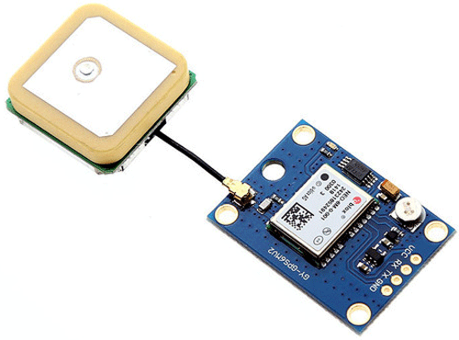

**5.2.2 GSM MODULE**

This is a GSM/GPRS-compatible Quad-band cell phone, which works on a frequency of 850/900/1800/1900MHz and which can be used for various applications such as access the Internet, make a voice call, send and receive SMS, etc. The frequency bands of the GSM modem can be set by AT Commands. The baud rate is configurable from 1200-115200 through AT command. The GSM/GPRS Modem is having an internal TCP/IP stack which enables us to connect with the internet via GPRS. This is an SMT type module and designed with a very powerful single-chip processor integrating AMR926EJ-S core, which is very popular in various industrial products.

**5.2.3 CIRCUIT ANALYSIS**

### **5.2.3.1 CONNECTION DIAGRAM**

**Women Safety system with GPS Tracking & Alerts** can be subdivided into two sections such as Transmitter and Receiver section. The circuit diagrams for each section is described as follows:

* 1. **Transmitter Section:**

In the RF Transmitter part, there will be an SOS button along with a 433 MHz RF transmitter, which will transmit the data to the receiver part wirelessly. The purpose of making two individual parts here is, to minimize the size of the transmitting module so that it can be worn as a wrist band. The circuit diagram for the transmitter part is shown below:

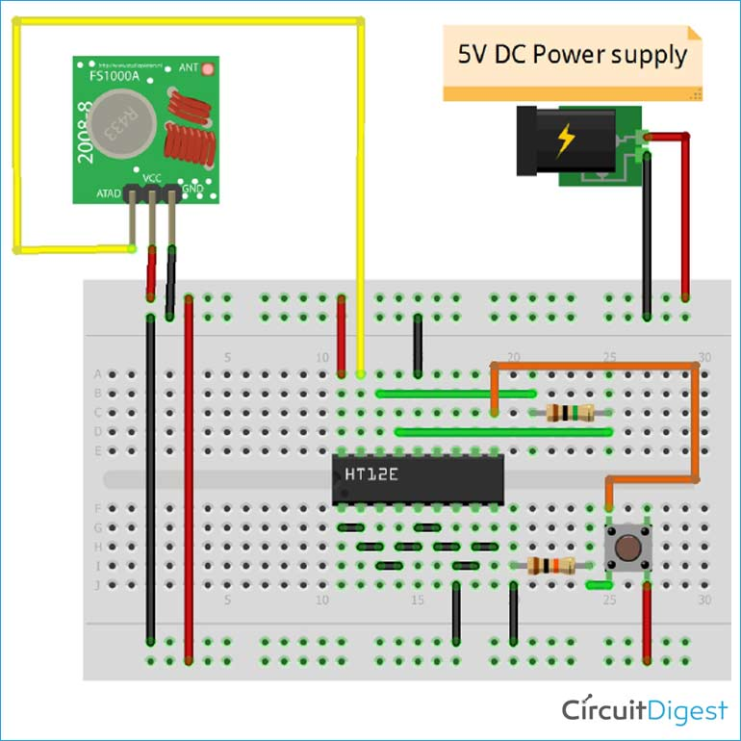

**Fig 5.2.3.1.1 Transmitter circuit diagram**

* 1. **Receiver Section:**

In the RF Receiver section, the data transmitted from the wrist band (Transmitter part) is received by the device having a 433 MHz RF receiver. The RF receiver sends this information to Arduino through the digital pin. Arduino Nano then receives the signal and processes it using the program which is flashed into it. When the victim presses the SOS button in the transmitter part, a HIGH signal is generated and passes to the Arduino side, and then Arduino sends a signal to SIM900 modem, to send an SMS to Registered user along with the GPS coordinate which has already been stored in the Microcontroller by the help of NEO6M GPS module. The circuit diagram of the Receiver side is shown as below:

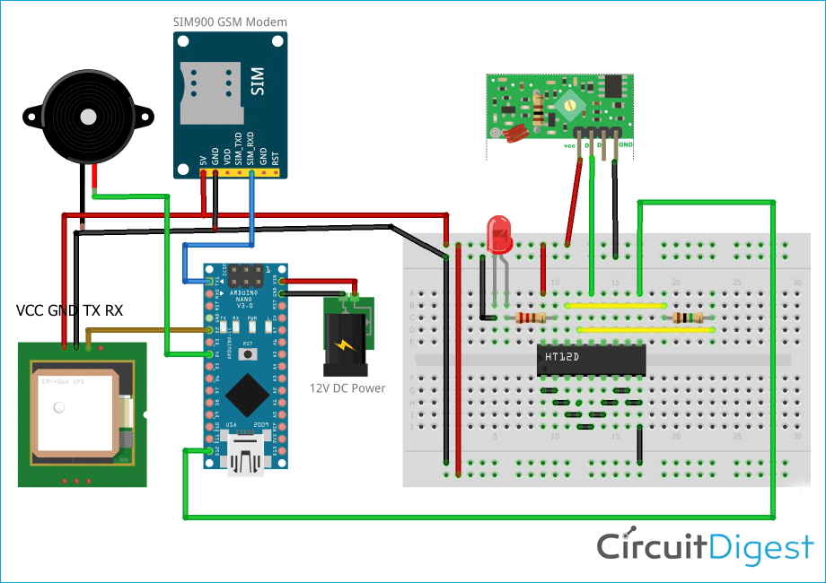

**Fig 5.2.3.1.2 Receiver circuit diagram**

**CHAPTER 6**

**SYSTEM DESIGN**

**6.1 DATA FLOW DIAGRAM**

Data flow diagram (DFD) is a graphical representation of the "flow" of data through an information system. It differs from the flowchart as it shows the data flow instead of the control flow of the program. A data flow diagram can also be used for the visualization of data processing. The DFD is designed to show how a system is divided into smaller portions and to highlight the flow of data between those parts.

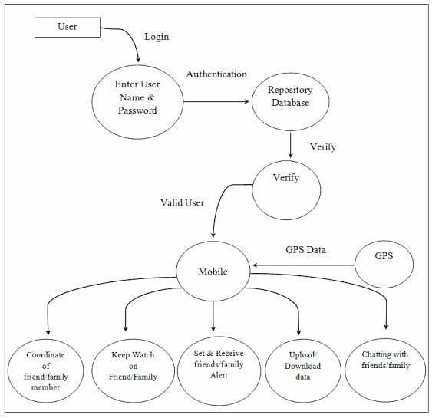

**Fig 6.1.1.2 Data Flow Diagram**

**6.2 UML DIAGRAM**

**6.2.1 USE CASE DIAGRAM**

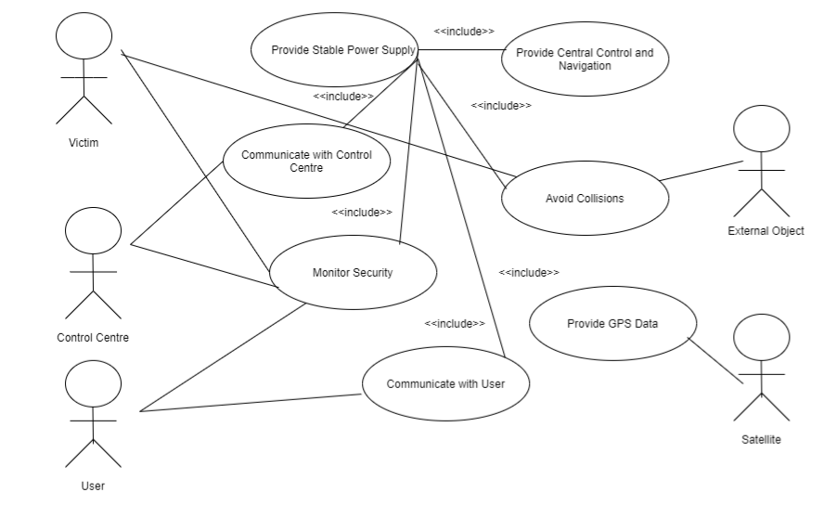

**Fig 6.2.1 UseCase Diagram**

**6.2.2 SEQUENCE DIAGRAM**

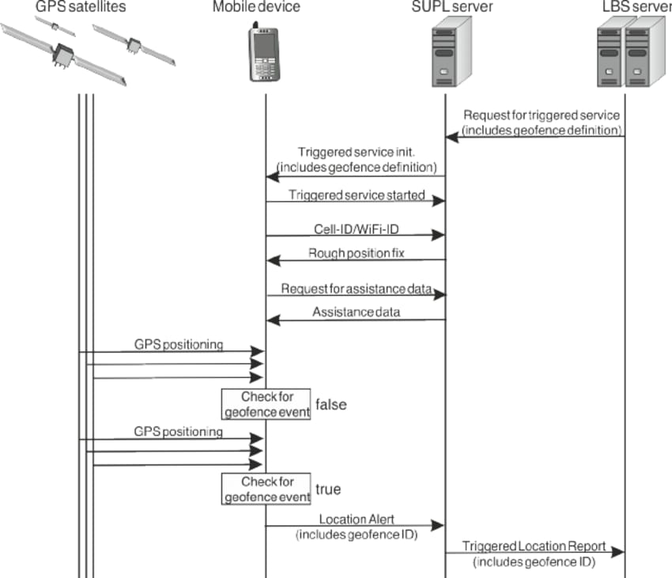

**Fig 6.2.2 Sequence Diagram**

**6.2.3 ACTIVITY DIAGRAM**

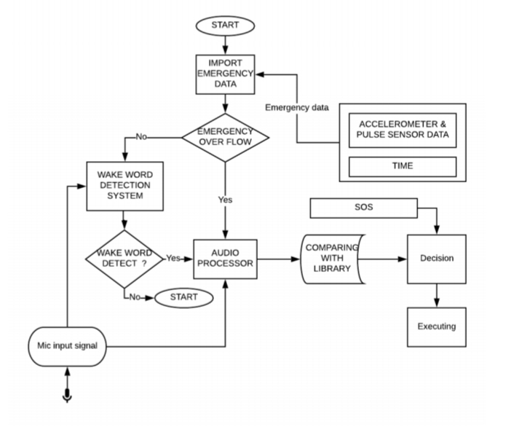

**Fig 6.2.3 Activity Diagram**

**6.2.4 CLASS DIAGRAM**

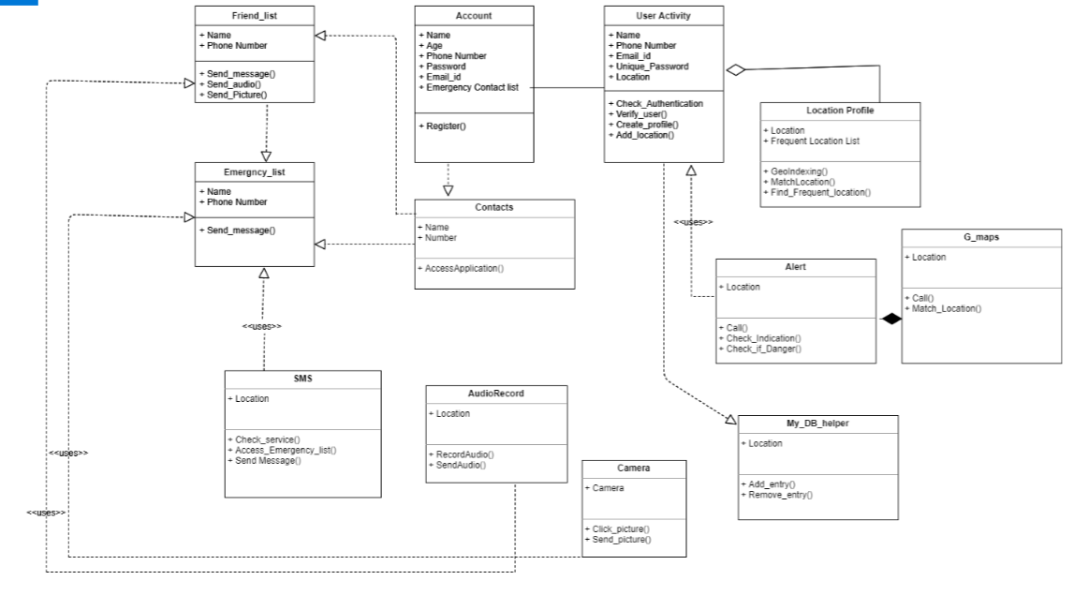

**Fig 6.2.4 Class Diagram**

**6.2.5 BLOCK DIAGRAM**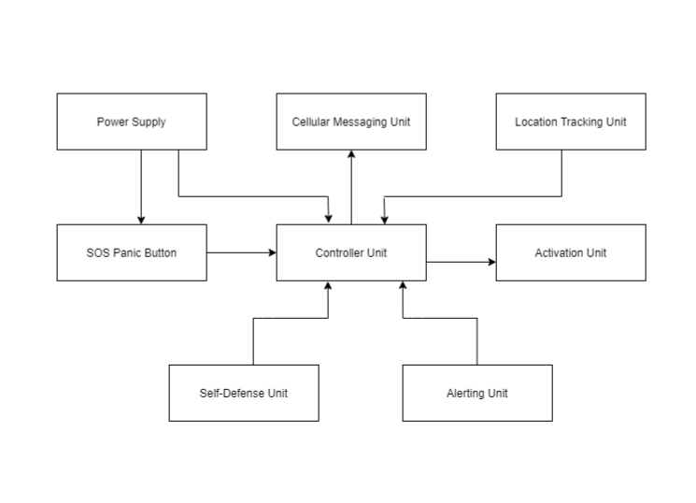

**Fig 6.2.4 Block Diagram**

**6.3 ALGORITHM**

STEP 1: Start.

STEP 2: Activate GPS Tracker by pressing ON/OFF Button.

STEP 3: Press SOS Panic Button.

STEP 4: Buzzer gets activated and it gives alert to GPS to read data.

STEP 5: GPS Tracker reads data.

STEP 6: GPS activates GSM SIM module to send SMS i.e alert message from victim to the user as “ HELP ME!! + (Geolocation of Victim)”.

STEP 7: User tracks the Victim’s Location.

STEP 8: Stop.

**6.4 FLOWCHART**

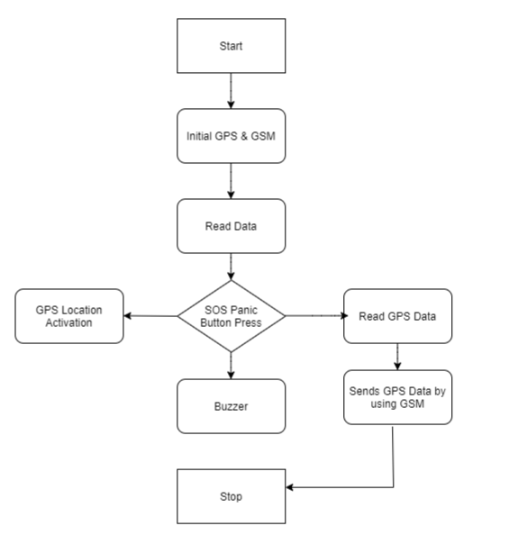

**Fig 6.4 Flow Chart**

**CHAPTER 7**

**SOFTWARE SYSTEM TESTING**

**7.1 TESTING OBJECTIVES**

Testing is the stage of implementation, which is aimed at ensuring that the system works accurately and efficiently before live operation commences. The logical design and physical design is thoroughly and continually examined on paper to ensure that they will work when implemented. Thus the system test in implementation was a confirmation that all is correct and an opportunity to show the users that the system works.

Testing of the online classified system was performed in three stages which are as follows:-

* Unit Testing
* Integration Testing
* System Testing

**7.2 SYSTEM TESTING**

System tests are designed to validate a fully developed system with a view to assuring that it meets its requirements. There are three types of system testing which are as follows:-

**Alpha Testing**

* The initial testing of a computer program or system under actual usage conditions, it can be done in-house by the vendor, or outside by a customer or third party teaser.
* Acceptance Testing performed by the customer in a controlled environment at the developer‘s site.
* The software used by the customer in a setting approximating the target environment with the developer observing and recording errors and usage problems.

**Beta Testing**

Beta Testing is done after alpha testing. The main purpose of Beta Testing is as follows:-

* Testing done by the potential or existing users, customers and end users at the external site without developers involvement is known as beta testing.
* It is operation testing i.e. it tests if the software satisfies the business or operational needs of the customers and end users.
* Beta Testing is done for external acceptance testing of COTS(Commercial off the Shelf) software.

**Test Case Design**

Any engineered product (and most other things) can be tested in one of the following two ways. Knowing the specified function that a product has been designed to perform, tests can be conducted to demonstrate each function is fully operational.

Knowing the internal working of a product, tests can be conducted to ensure that ―all gears mesh‖, that is the internal operation of the product performs according to the specification and all internal components have been adequately exercised.

**7.3 TESTING LEVELS**

**7.3.1 UNIT TESTING**

Unit testing is under taken when a module has been coded and successfully reviewed. This can be done by two methods:

1. Black Box testing
2. Equivalence Class Partitioning

a) **Black Box Testing**

Test cases are designed from an examination of the input/output values only and no knowledge of designing or coding is required the following are the two main approaches of designing black-box test cases.

***b) Equivalence Class Partitioning***

The domain of input values to a program is partitioned into a set of equivalence classes. This partitioning is done on such way that the behaviour of the program is similar to every boundary value analysis. Boundary value analysis leads to selection of the test cases at the boundaries of different equivalence classes.

Testing done by: Team Member

**7.3.2 INTEGRATION TESTING**

During integration testing different modules of the system are integrated using integration plan. The integration plan specifies the steps and the order in which modules are combined to realize the full system.

Purpose:

* To test whether the module performs its intended task.
* Once all the modules have been integrated and tested, system testing can start.

**7.3.3 VALIDATION TESTING**

The output generated is validated with the minimum support count and confidence. The frequent patterns generated by Apriori is validated with Eclat algorithm. In the same way, the association rules are also validated.

There are also different types of testing. They are

**White Box Testing:**

White-box testing is a methodology used to ensure and validate the internal framework, mechanisms, objects and components of a software application. White-box testing verifies code according to design specifications and uncovers application vulnerabilities.

White-box testing is also known as transparent box testing, clear box testing, structural testing and glass box testing. Glass box and clear box indicate that internal mechanisms are visible to a software engineering team.

White-box testing advantages include:

* Enables test case reusability and delivers greater stability
* Facilitates code optimization
* Facilitates finding of the locations of hidden errors in early phases of development
* Facilitates effective application testing
* Removes unnecessary lines of code

**Regression Testing :**

It is a type of software testing i.e. carried out by software testers as functional regression tests & developers as Unit Regression Tests. Objective of regression tests are to find defects that got introduced to detect fixes or introduction of new features. Regression tests are ideal candidate for automation

**Accessibility Testing :**

This is a formal type of software testing that helps to determine whether the software can be used by people with disability. There are also companies & consultants that provide website accessibility audits.

**Ad-hoc Testing :**

Ad hoc testing is an informal and improvisational approach to assessing the viability of a product. An ad-hoc is usually only conducted once unless a defect is found. Commonly used in software development, ad hoc testing is performed without a plan of action and any actions taken are not typically documented. Testers may not have detailed knowledge of product requirements. Ad hoc testing is also referred to as random testing and monkey testing.

**CHAPTER 8**

**CONCLUSION AND FUTURE ENHANCEMENT**

The project was developed incorporating the characteristics of all the hardware components used and designed. The presence of each module has been reasoned and placed carefully to obtain the best operation of the unit. Secondly, using a highly advanced module and with the help of growing technology, the project has been successfully implemented. Now a day's harassment is a big issue in the world. Sometimes, women, children are facing various kinds of abusing, violation in daily basis. So, the safety assistant and harassment prevention device might be a solution of this problem. We conclude that safety assistant and harassment prevention device is the part of the electronics field which has huge scope for research and development. It has large possibility of future researches for further development of the project. There are many more suggestions for this project also. Some limitation should maintain properly so that the project can run successfully. It can be further advanced by using biomedical instrument which can develop the project. It has many developing parts that help to contribute some benefit in the social development, if anyone wants to add biomedical components, it will help to save millions of lives in the critical situation. This concept can be extended in the future by various type sensor and equipment. So, the main achievement of this project is ensuring the safety of the victim of some intense situation by tracking their location and providing them proper support instantly. And this hairband is replaceable thus it can be made easier for replacement.

**APPENDIX A: SOURCE CODE**

**#AURDINO PROGRAM**

#include <LiquidCrystal.h>

#include <TinyGPS++.h>

#include <SoftwareSerial.h>

static const int RXPin = 2, TXPin = 3;

static const uint32_t gps_baudrate = 9600;

TinyGPSPlus gps;

SoftwareSerial soft(RXPin, TXPin);

String textMessage;

float Lat, Lon;

void setup()

{

soft.begin(gps_baudrate);

Serial.begin(19200);

pinMode(12,INPUT);

pinMode(4, OUTPUT);

}

void loop()

{

int key = digitalRead(12);

while (soft.available() > 0)

{

gps.encode(soft.read());

if (gps.location.isUpdated())

{

Lat = gps.location.lat();

Lon = gps.location.lng();

}

else;

}

if(key==1)

{

digitalWrite(4,HIGH);

sendsms();

digitalWrite(4,LOW);

}

}

void sendsms()

{

Serial.print("AT+CMGF=1\r");

delay(100);

Serial.println("AT+CMGS =\"+9194XXXXXX\"");

delay(100);

Serial.println("I want Help !!!Location:" + String("Lat: ") +String(Lat) + " "+String("Lon: ") + String(Lon));

delay(100);

Serial.println((char)26);

delay(100);

Serial.println();

delay(5000);

}

**LIBRARIES:**

**LIBRARY FILE 1:**

**#include "TinyGPS++.h"**

#include <string.h>

#include <ctype.h>

#include <stdlib.h>

#define _GPRMCterm "GPRMC"

#define _GPGGAterm "GPGGA"

#define _GNRMCterm "GNRMC"

#define _GNGGAterm "GNGGA"

TinyGPSPlus::TinyGPSPlus()

: parity(0)

, isChecksumTerm(false)

, curSentenceType(GPS_SENTENCE_OTHER)

, curTermNumber(0)

, curTermOffset(0)

, sentenceHasFix(false)

, customElts(0)

, customCandidates(0)

, encodedCharCount(0)

, sentencesWithFixCount(0)

, failedChecksumCount(0)

, passedChecksumCount(0)

{

term[0] = '\0';

}

//

// public methods

//

bool TinyGPSPlus::encode(char c)

{

++encodedCharCount;

switch(c)

{

case ',': // term terminators

parity ^= (uint8_t)c;

case '\r':

case '\n':

case '*':

{

bool isValidSentence = false;

if (curTermOffset < sizeof(term))

{

term[curTermOffset] = 0;

isValidSentence = endOfTermHandler();

}

++curTermNumber;

curTermOffset = 0;

isChecksumTerm = c == '*';

return isValidSentence;

}

break;

case '$': // sentence begin

curTermNumber = curTermOffset = 0;

parity = 0;

curSentenceType = GPS_SENTENCE_OTHER;

isChecksumTerm = false;

sentenceHasFix = false;

return false;

default: // ordinary characters

if (curTermOffset < sizeof(term) - 1)

term[curTermOffset++] = c;

if (!isChecksumTerm)

parity ^= c;

return false;

}

return false;

}

//

// internal utilities

//

int TinyGPSPlus::fromHex(char a)

{

if (a >= 'A' && a <= 'F')

return a - 'A' + 10;

else if (a >= 'a' && a <= 'f')

return a - 'a' + 10;

else

return a - '0';

}

// static

// Parse a (potentially negative) number with up to 2 decimal digits -xxxx.yy

int32_t TinyGPSPlus::parseDecimal(const char *term)

{

bool negative = *term == '-';

if (negative) ++term;

int32_t ret = 100 * (int32_t)atol(term);

while (isdigit(*term)) ++term;

if (*term == '.' && isdigit(term[1]))

{

ret += 10 * (term[1] - '0');

if (isdigit(term[2]))

ret += term[2] - '0';

}

return negative ? -ret : ret;

}

// static

// Parse degrees in that funny NMEA format DDMM.MMMM

void TinyGPSPlus::parseDegrees(const char *term, RawDegrees &deg)

{

uint32_t leftOfDecimal = (uint32_t)atol(term);

uint16_t minutes = (uint16_t)(leftOfDecimal % 100);

uint32_t multiplier = 10000000UL;

uint32_t tenMillionthsOfMinutes = minutes * multiplier;

deg.deg = (int16_t)(leftOfDecimal / 100);

while (isdigit(*term))

++term;

if (*term == '.')

while (isdigit(*++term))

{

multiplier /= 10;

tenMillionthsOfMinutes += (*term - '0') * multiplier;

}

deg.billionths = (5 * tenMillionthsOfMinutes + 1) / 3;

deg.negative = false;

}

#define COMBINE(sentence_type, term_number) (((unsigned)(sentence_type) << 5) | term_number)

// Processes a just-completed term

// Returns true if new sentence has just passed checksum test and is validated

bool TinyGPSPlus::endOfTermHandler()

{

// If it's the checksum term, and the checksum checks out, commit

if (isChecksumTerm)

{

byte checksum = 16 * fromHex(term[0]) + fromHex(term[1]);

if (checksum == parity)

{

passedChecksumCount++;

if (sentenceHasFix)

++sentencesWithFixCount;

switch(curSentenceType)

{

case GPS_SENTENCE_GPRMC:

date.commit();

time.commit();

if (sentenceHasFix)

{

location.commit();

speed.commit();

course.commit();

}

break;

case GPS_SENTENCE_GPGGA:

time.commit();

if (sentenceHasFix)

{

location.commit();

altitude.commit();

}

satellites.commit();

hdop.commit();

break;

}

// Commit all custom listeners of this sentence type

for (TinyGPSCustom *p = customCandidates; p != NULL && strcmp(p->sentenceName, customCandidates->sentenceName) == 0; p = p->next)

p->commit();

return true;

}

else

{

++failedChecksumCount;

}

return false;

}

// the first term determines the sentence type

if (curTermNumber == 0)

{

if (!strcmp(term, _GPRMCterm) || !strcmp(term, _GNRMCterm))

curSentenceType = GPS_SENTENCE_GPRMC;

else if (!strcmp(term, _GPGGAterm) || !strcmp(term, _GNGGAterm))

curSentenceType = GPS_SENTENCE_GPGGA;

else

curSentenceType = GPS_SENTENCE_OTHER;

// Any custom candidates of this sentence type?

for (customCandidates = customElts; customCandidates != NULL && strcmp(customCandidates->sentenceName, term) < 0; customCandidates = customCandidates->next);

if (customCandidates != NULL && strcmp(customCandidates->sentenceName, term) > 0)

customCandidates = NULL;

return false;

}

if (curSentenceType != GPS_SENTENCE_OTHER && term[0])

switch(COMBINE(curSentenceType, curTermNumber))

{

case COMBINE(GPS_SENTENCE_GPRMC, 1): // Time in both sentences

case COMBINE(GPS_SENTENCE_GPGGA, 1):

time.setTime(term);

break;

case COMBINE(GPS_SENTENCE_GPRMC, 2): // GPRMC validity

sentenceHasFix = term[0] == 'A';

break;

case COMBINE(GPS_SENTENCE_GPRMC, 3): // Latitude

case COMBINE(GPS_SENTENCE_GPGGA, 2):

location.setLatitude(term);

break;

case COMBINE(GPS_SENTENCE_GPRMC, 4): // N/S

case COMBINE(GPS_SENTENCE_GPGGA, 3):

location.rawNewLatData.negative = term[0] == 'S';

break;

case COMBINE(GPS_SENTENCE_GPRMC, 5): // Longitude

case COMBINE(GPS_SENTENCE_GPGGA, 4):

location.setLongitude(term);

break;

case COMBINE(GPS_SENTENCE_GPRMC, 6): // E/W

case COMBINE(GPS_SENTENCE_GPGGA, 5):

location.rawNewLngData.negative = term[0] == 'W';

break;

case COMBINE(GPS_SENTENCE_GPRMC, 7): // Speed (GPRMC)

speed.set(term);

break;

case COMBINE(GPS_SENTENCE_GPRMC, 8): // Course (GPRMC)

course.set(term);

break;

case COMBINE(GPS_SENTENCE_GPRMC, 9): // Date (GPRMC)

date.setDate(term);

break;

case COMBINE(GPS_SENTENCE_GPGGA, 6): // Fix data (GPGGA)

sentenceHasFix = term[0] > '0';

break;

case COMBINE(GPS_SENTENCE_GPGGA, 7): // Satellites used (GPGGA)

satellites.set(term);

break;

case COMBINE(GPS_SENTENCE_GPGGA, 8): // HDOP

hdop.set(term);

break;

case COMBINE(GPS_SENTENCE_GPGGA, 9): // Altitude (GPGGA)

altitude.set(term);

break;

}

// Set custom values as needed

for (TinyGPSCustom *p = customCandidates; p != NULL && strcmp(p->sentenceName, customCandidates->sentenceName) == 0 && p->termNumber <= curTermNumber; p = p->next)

if (p->termNumber == curTermNumber)

p->set(term);

return false;

}

/* static */

double TinyGPSPlus::distanceBetween(double lat1, double long1, double lat2, double long2)

{

// returns distance in meters between two positions, both specified

// as signed decimal-degrees latitude and longitude. Uses great-circle

// distance computation for hypothetical sphere of radius 6372795 meters.

// Because Earth is no exact sphere, rounding errors may be up to 0.5%.

// Courtesy of Maarten Lamers

double delta = radians(long1-long2);

double sdlong = sin(delta);

double cdlong = cos(delta);

lat1 = radians(lat1);

lat2 = radians(lat2);

double slat1 = sin(lat1);

double clat1 = cos(lat1);

double slat2 = sin(lat2);

double clat2 = cos(lat2);

delta = (clat1 * slat2) - (slat1 * clat2 * cdlong);

delta = sq(delta);

delta += sq(clat2 * sdlong);

delta = sqrt(delta);

double denom = (slat1 * slat2) + (clat1 * clat2 * cdlong);

delta = atan2(delta, denom);

return delta * 6372795;

}

double TinyGPSPlus::courseTo(double lat1, double long1, double lat2, double long2)

{

// returns course in degrees (North=0, West=270) from position 1 to position 2,

// both specified as signed decimal-degrees latitude and longitude.

// Because Earth is no exact sphere, calculated course may be off by a tiny fraction.

// Courtesy of Maarten Lamers

double dlon = radians(long2-long1);

lat1 = radians(lat1);

lat2 = radians(lat2);

double a1 = sin(dlon) * cos(lat2);

double a2 = sin(lat1) * cos(lat2) * cos(dlon);

a2 = cos(lat1) * sin(lat2) - a2;

a2 = atan2(a1, a2);

if (a2 < 0.0)

{

a2 += TWO_PI;

}

return degrees(a2);

}

const char *TinyGPSPlus::cardinal(double course)

{

static const char* directions[] = {"N", "NNE", "NE", "ENE", "E", "ESE", "SE", "SSE", "S", "SSW", "SW", "WSW", "W", "WNW", "NW", "NNW"};

int direction = (int)((course + 11.25f) / 22.5f);

return directions[direction % 16];

}

void TinyGPSLocation::commit()

{

rawLatData = rawNewLatData;

rawLngData = rawNewLngData;

lastCommitTime = millis();

valid = updated = true;

}

void TinyGPSLocation::setLatitude(const char *term)

{

TinyGPSPlus::parseDegrees(term, rawNewLatData);

}

void TinyGPSLocation::setLongitude(const char *term)

{

TinyGPSPlus::parseDegrees(term, rawNewLngData);

}

double TinyGPSLocation::lat()

{

updated = false;

double ret = rawLatData.deg + rawLatData.billionths / 1000000000.0;

return rawLatData.negative ? -ret : ret;

}

double TinyGPSLocation::lng()

{

updated = false;

double ret = rawLngData.deg + rawLngData.billionths / 1000000000.0;

return rawLngData.negative ? -ret : ret;

}

void TinyGPSDate::commit()

{

date = newDate;

lastCommitTime = millis();

valid = updated = true;

}

void TinyGPSTime::commit()

{

time = newTime;

lastCommitTime = millis();

valid = updated = true;

}

void TinyGPSTime::setTime(const char *term)

{

newTime = (uint32_t)TinyGPSPlus::parseDecimal(term);

}

void TinyGPSDate::setDate(const char *term)

{

newDate = atol(term);

}

uint16_t TinyGPSDate::year()

{

updated = false;

uint16_t year = date % 100;

return year + 2000;

}

uint8_t TinyGPSDate::month()

{

updated = false;

return (date / 100) % 100;

}

uint8_t TinyGPSDate::day()

{

updated = false;

return date / 10000;

}

uint8_t TinyGPSTime::hour()

{

updated = false;

return time / 1000000;

}

uint8_t TinyGPSTime::minute()

{

updated = false;

return (time / 10000) % 100;

}

uint8_t TinyGPSTime::second()

{

updated = false;

return (time / 100) % 100;

}

uint8_t TinyGPSTime::centisecond()

{

updated = false;

return time % 100;

}

void TinyGPSDecimal::commit()

{

val = newval;

lastCommitTime = millis();

valid = updated = true;

}

void TinyGPSDecimal::set(const char *term)

{

newval = TinyGPSPlus::parseDecimal(term);

}

void TinyGPSInteger::commit()

{

val = newval;

lastCommitTime = millis();

valid = updated = true;

}

void TinyGPSInteger::set(const char *term)

{

newval = atol(term);

}

TinyGPSCustom::TinyGPSCustom(TinyGPSPlus &gps, const char *_sentenceName, int _termNumber)

{

begin(gps, _sentenceName, _termNumber);

}

void TinyGPSCustom::begin(TinyGPSPlus &gps, const char *_sentenceName, int _termNumber)

{

lastCommitTime = 0;

updated = valid = false;

sentenceName = _sentenceName;

termNumber = _termNumber;

memset(stagingBuffer, '\0', sizeof(stagingBuffer));

memset(buffer, '\0', sizeof(buffer));

// Insert this item into the GPS tree

gps.insertCustom(this, _sentenceName, _termNumber);

}

void TinyGPSCustom::commit()

{

strcpy(this->buffer, this->stagingBuffer);

lastCommitTime = millis();

valid = updated = true;

}

void TinyGPSCustom::set(const char *term)

{

strncpy(this->stagingBuffer, term, sizeof(this->stagingBuffer));

}

void TinyGPSPlus::insertCustom(TinyGPSCustom *pElt, const char *sentenceName, int termNumber)

{

TinyGPSCustom **ppelt;

for (ppelt = &this->customElts; *ppelt != NULL; ppelt = &(*ppelt)->next)

{

int cmp = strcmp(sentenceName, (*ppelt)->sentenceName);

if (cmp < 0 || (cmp == 0 && termNumber < (*ppelt)->termNumber))

break;

}

pElt->next = *ppelt;

*ppelt = pElt;

}

**LIBRARY FILE 2:**

**#ifndef __TinyGPSPlus_h**

**#define __TinyGPSPlus_h**

#if defined(ARDUINO) && ARDUINO >= 100

#include "Arduino.h"

#else

#include "WProgram.h"

#endif

#include <limits.h>

#define _GPS_VERSION "1.0.2" // software version of this library

#define _GPS_MPH_PER_KNOT 1.15077945

#define _GPS_MPS_PER_KNOT 0.51444444

#define _GPS_KMPH_PER_KNOT 1.852

#define _GPS_MILES_PER_METER 0.00062137112

#define _GPS_KM_PER_METER 0.001

#define _GPS_FEET_PER_METER 3.2808399

#define _GPS_MAX_FIELD_SIZE 15

struct RawDegrees

{

uint16_t deg;

uint32_t billionths;

bool negative;

public:

RawDegrees() : deg(0), billionths(0), negative(false)

{}

};

struct TinyGPSLocation

{

friend class TinyGPSPlus;

public:

bool isValid() const { return valid; }

bool isUpdated() const { return updated; }

uint32_t age() const { return valid ? millis() - lastCommitTime : (uint32_t)ULONG_MAX; }

const RawDegrees &rawLat() { updated = false; return rawLatData; }

const RawDegrees &rawLng() { updated = false; return rawLngData; }

double lat();

double lng();

TinyGPSLocation() : valid(false), updated(false)

{}

private:

bool valid, updated;

RawDegrees rawLatData, rawLngData, rawNewLatData, rawNewLngData;

uint32_t lastCommitTime;

void commit();

void setLatitude(const char *term);

void setLongitude(const char *term);

};

struct TinyGPSDate

{

friend class TinyGPSPlus;

public:

bool isValid() const { return valid; }

bool isUpdated() const { return updated; }

uint32_t age() const { return valid ? millis() - lastCommitTime : (uint32_t)ULONG_MAX; }

uint32_t value() { updated = false; return date; }

uint16_t year();

uint8_t month();

uint8_t day();

TinyGPSDate() : valid(false), updated(false), date(0)

{}

private:

bool valid, updated;

uint32_t date, newDate;

uint32_t lastCommitTime;

void commit();

void setDate(const char *term);

};

struct TinyGPSTime

{

friend class TinyGPSPlus;

public:

bool isValid() const { return valid; }

bool isUpdated() const { return updated; }

uint32_t age() const { return valid ? millis() - lastCommitTime : (uint32_t)ULONG_MAX; }

uint32_t value() { updated = false; return time; }

uint8_t hour();

uint8_t minute();

uint8_t second();

uint8_t centisecond();

TinyGPSTime() : valid(false), updated(false), time(0)

{}

private:

bool valid, updated;

uint32_t time, newTime;

uint32_t lastCommitTime;

void commit();

void setTime(const char *term);

};

struct TinyGPSDecimal

{

friend class TinyGPSPlus;

public:

bool isValid() const { return valid; }

bool isUpdated() const { return updated; }

uint32_t age() const { return valid ? millis() - lastCommitTime : (uint32_t)ULONG_MAX; }

int32_t value() { updated = false; return val; }

TinyGPSDecimal() : valid(false), updated(false), val(0)

{}

private:

bool valid, updated;

uint32_t lastCommitTime;

int32_t val, newval;

void commit();

void set(const char *term);

};

struct TinyGPSInteger

{

friend class TinyGPSPlus;

public:

bool isValid() const { return valid; }

bool isUpdated() const { return updated; }

uint32_t age() const { return valid ? millis() - lastCommitTime : (uint32_t)ULONG_MAX; }

uint32_t value() { updated = false; return val; }

TinyGPSInteger() : valid(false), updated(false), val(0)

{}

private:

bool valid, updated;

uint32_t lastCommitTime;

uint32_t val, newval;

void commit();

void set(const char *term);

};

struct TinyGPSSpeed : TinyGPSDecimal

{

double knots() { return value() / 100.0; }

double mph() { return _GPS_MPH_PER_KNOT * value() / 100.0; }

double mps() { return _GPS_MPS_PER_KNOT * value() / 100.0; }

double kmph() { return _GPS_KMPH_PER_KNOT * value() / 100.0; }

};

struct TinyGPSCourse : public TinyGPSDecimal

{

double deg() { return value() / 100.0; }

};

struct TinyGPSAltitude : TinyGPSDecimal

{

double meters() { return value() / 100.0; }

double miles() { return _GPS_MILES_PER_METER * value() / 100.0; }

double kilometers() { return _GPS_KM_PER_METER * value() / 100.0; }

double feet() { return _GPS_FEET_PER_METER * value() / 100.0; }

};

struct TinyGPSHDOP : TinyGPSDecimal

{

double hdop() { return value() / 100.0; }

};

class TinyGPSPlus;

class TinyGPSCustom

{

public:

TinyGPSCustom() {};

TinyGPSCustom(TinyGPSPlus &gps, const char *sentenceName, int termNumber);

void begin(TinyGPSPlus &gps, const char *_sentenceName, int _termNumber);

bool isUpdated() const { return updated; }

bool isValid() const { return valid; }

uint32_t age() const { return valid ? millis() - lastCommitTime : (uint32_t)ULONG_MAX; }

const char *value() { updated = false; return buffer; }

private:

void commit();

void set(const char *term);

char stagingBuffer[_GPS_MAX_FIELD_SIZE + 1];

char buffer[_GPS_MAX_FIELD_SIZE + 1];

unsigned long lastCommitTime;

bool valid, updated;

const char *sentenceName;

int termNumber;

friend class TinyGPSPlus;

TinyGPSCustom *next;

};

class TinyGPSPlus

{

public:

TinyGPSPlus();

bool encode(char c); // process one character received from GPS

TinyGPSPlus &operator << (char c) {encode(c); return *this;}

TinyGPSLocation location;

TinyGPSDate date;

TinyGPSTime time;

TinyGPSSpeed speed;

TinyGPSCourse course;

TinyGPSAltitude altitude;

TinyGPSInteger satellites;

TinyGPSHDOP hdop;

static const char *libraryVersion() { return _GPS_VERSION; }

static double distanceBetween(double lat1, double long1, double lat2, double long2);

static double courseTo(double lat1, double long1, double lat2, double long2);

static const char *cardinal(double course);

static int32_t parseDecimal(const char *term);

static void parseDegrees(const char *term, RawDegrees &deg);

uint32_t charsProcessed() const { return encodedCharCount; }

uint32_t sentencesWithFix() const { return sentencesWithFixCount; }

uint32_t failedChecksum() const { return failedChecksumCount; }

uint32_t passedChecksum() const { return passedChecksumCount; }

private:

enum {GPS_SENTENCE_GPGGA, GPS_SENTENCE_GPRMC, GPS_SENTENCE_OTHER};

// parsing state variables

uint8_t parity;

bool isChecksumTerm;

char term[_GPS_MAX_FIELD_SIZE];

uint8_t curSentenceType;

uint8_t curTermNumber;

uint8_t curTermOffset;

bool sentenceHasFix;

// custom element support

friend class TinyGPSCustom;

TinyGPSCustom *customElts;

TinyGPSCustom *customCandidates;

void insertCustom(TinyGPSCustom *pElt, const char *sentenceName, int index);

// statistics

uint32_t encodedCharCount;

uint32_t sentencesWithFixCount;

uint32_t failedChecksumCount;

uint32_t passedChecksumCount;

// internal utilities

int fromHex(char a);

bool endOfTermHandler();

};

#endif // def(__TinyGPSPlus_h)

**APPENDIX B : SNAP SHOTS**

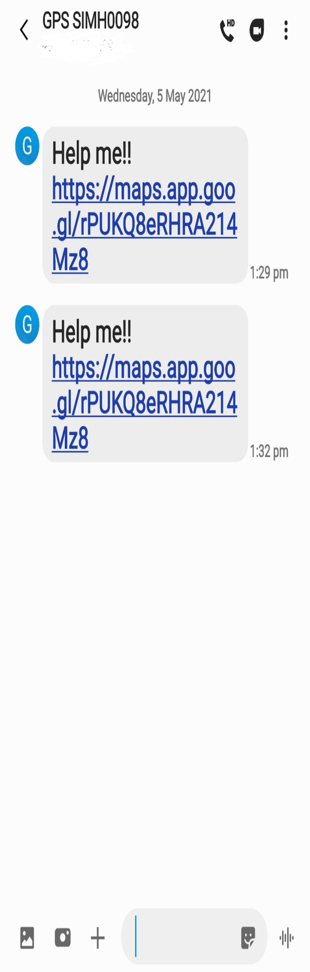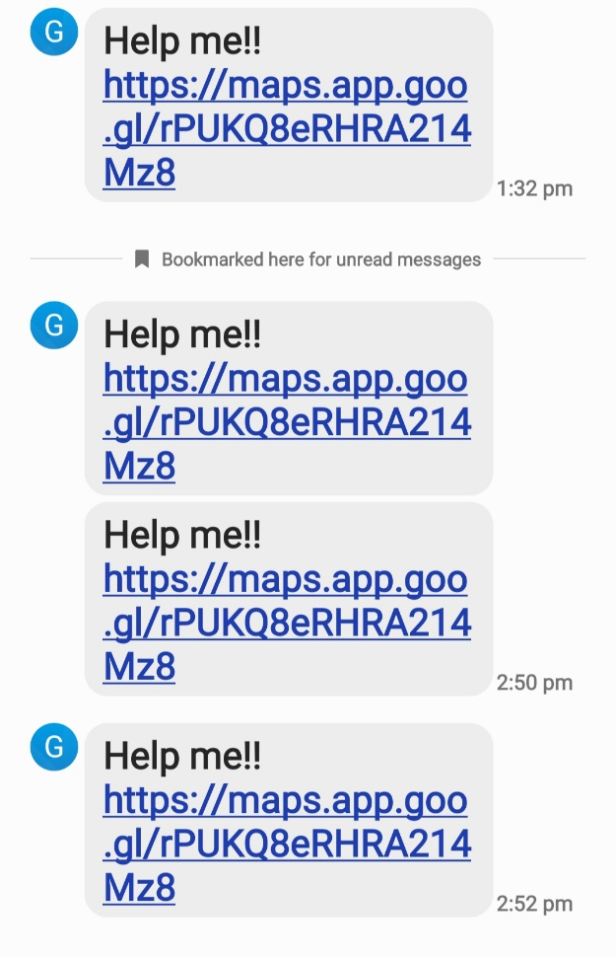

**Fig 8.1 Alert Message Received**

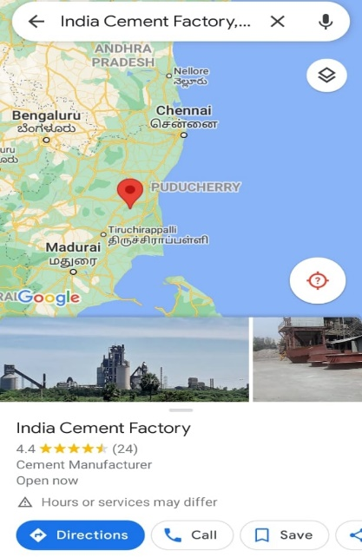 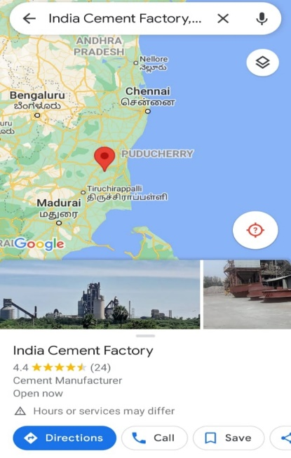

**Fig 8.2 Location Tracked in Google Map**

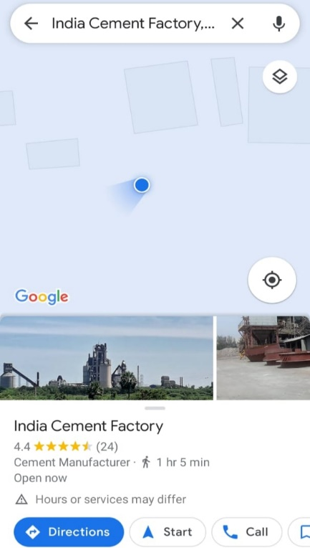 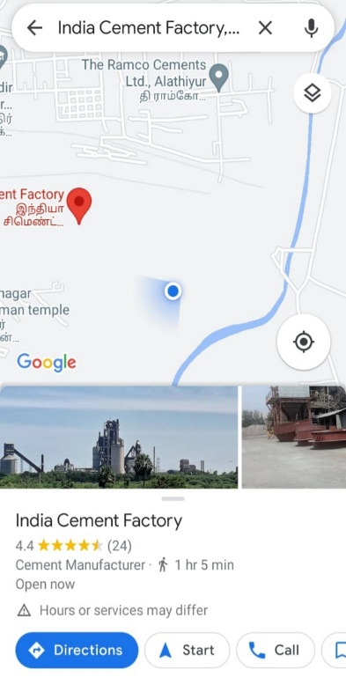

**Fig 8.3 Exact Location of Victim is tracked**

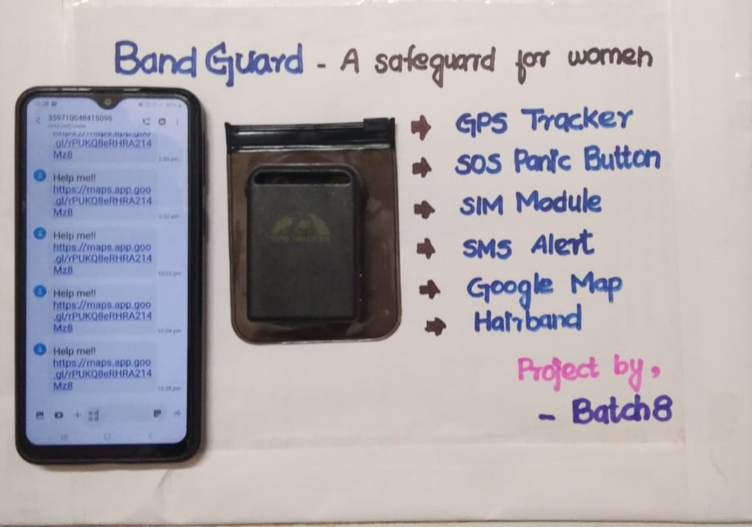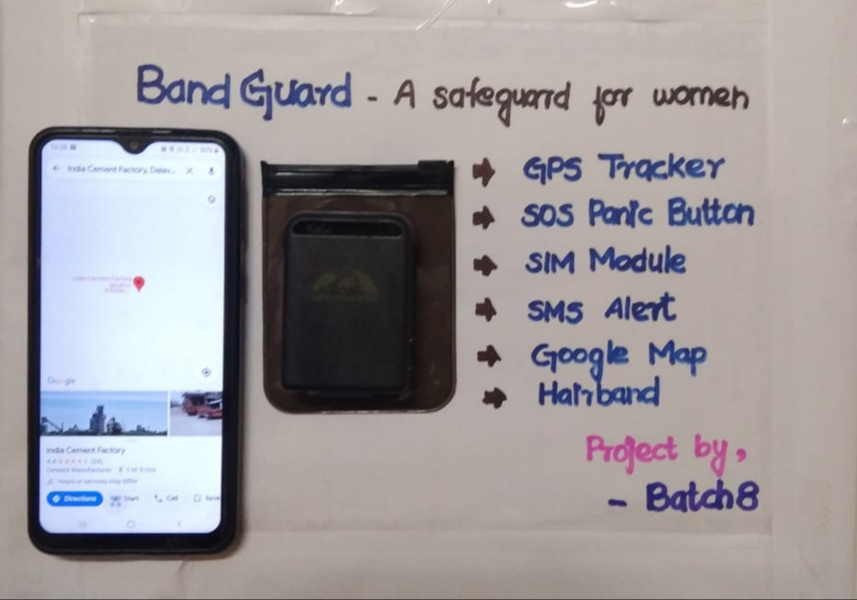

**Fig 8.4,8.5 Band_Gaurd Implementation Outcome**

**REFERENCES**

1)Design and implementation of safety armband for women and children using ARM7Glenson Toney ; Fathima Jabeen ; Puneeth S 2015 International Conference on Power and Advanced Control Engineering(ICPACE)Year:2015.

2)Design of a women safety device Divya Chitkara ;Nipun Sachdeva ; Yash Dev Vashisht 2016 IEEE Region10 Humanitarian Technology Conference(R10-HTC)Year:2016.

3) A mobile application for Women's Safety: WoSApp Dhruv Chand ;Sunil Nayak ; Karthik S. Bhat ; Shivani Parikh ; Yuvraj Singh ; AmitaAjith Kamath TENCON 2015 - 2015 IEEE Region 10 Conference Year:2015

4) Mr. Vaibhav A. A Study Based on Women Security System

<http://ijsetr.org/wpcontent/uploads/2017/08/IJSETR-VOL-6-ISSUE-8-1241-1243.pdf>

5)Electronic Device for Women Safety”- Times of India, Sep15 2013. <https://www.ijireeice.com/upload/2016/march-16/IJIREEICE%208.pdf>

6) G C Harikrian ,ECE Department ,Smart security solution for

women India

<https://ieeeexplore.teee.org/document/7755365/author#authors>

7) Smart foot device for women safety Nandita Viswanath;Naga Vaishnavi Pakyala ; G. Muneeswari 2016 IEEE Region 10 Symposium (TENSYMP) Year:2016.

8) Abhijit Paradkar, K.J.Somaiya & Deepak Sharma, “All in one Intelligent Safety System for Women Security”, International Journal of Computer Applications, Vol. 130, Issue 11, November 2015

9) Shubham Magidwar, Akshay Hargane, Pratik Singh, Mrudula Nade & Rama Gaikwad,“ Implementation of a Wearable Defense System for Women’s Security using Wireless Sensor Network”, International Research Journal of Engineering and Technology (IRJET), Vol.3, Issue 11, Nov 2016, pp. 1217-1221.

10) Bhardwaj, N., &Aggarwal, N. (2014). Design and Development of “Suraksha”-A Women Safety Device. International Journal of Information & Computational Technology, 4(8), 787-792.